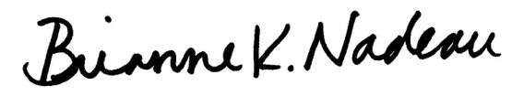
___________________________ _________________________ Councilmember Janeese Lewis George Councilmember Brianne K. Nadeau

______________________________ ___________________________
Councilmember Christina Henderson Councilmember Brooke Pinto
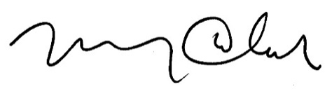

________________________ ___________________________
Councilmember Mary M. Cheh Councilmember Robert C. White, Jr.

A BILL

_________________________

IN THE COUNCIL OF THE DISTRICT OF COLUMBIA

_________________________

To amend the Prevention of Child Abuse and Neglect Act of 1977 to require the Child and Family Services Agency to implement the Foster Youth to Independence Initiative.

BE IT ENACTED BY THE COUNCIL OF THE DISTRICT OF COLUMBIA, That this
act may be cited as the “Fostering Stable Housing Opportunities Amendment Act of 2022”.
Sec. 2. The Prevention of Child Abuse and Neglect Act of 1977, effective September 23, 1977 (D.C. Law 2-22; D.C. Official Code § 4-1301.01 et seq.), is amended as follows:
(a) A new section 303g is added to read as follows:
“Sec. 303g. Housing for youth aging out of Agency custody.
“(a) When a youth who has left foster care in accordance with a transition plan described in section 475(5)(H) of the Social Security Act, or who is within 90 days of leaving foster care in accordance with a transition plan described in section 475(5)(H) of the Social Security Act, is at risk of homelessness and requires assistance securing a primary residence for independent living other than a college dormitory or military housing before, or within five years of, leaving foster care, the Agency shall collaborate with the District of Columbia Housing Authority to take any action necessary to secure for the youth a Family Unification Program Housing Choice Voucher provided through the Foster Youth to Independence Initiative.
“(b) The Agency shall engage in any action required by the United Sates Department of Housing and Urban Development to administer the Foster Youth to Independence Initiative in collaboration with the District of Columbia Housing Authority, including, but not limited to:
“(1) Providing or securing any required supportive services for participating youth for the duration of the youth’s use of a Foster Youth to Independence voucher;
“(2) Providing a written certification to the District of Columbia Housing Authority verifying the youth’s child welfare history; and
“(3) Identifying any youth eligible for a Foster Youth to Independence Initiative voucher within the Agency’s caseload and communicating the existence of eligibility to eligible youth.”.
Sec. 3. Fiscal impact statement.
The Council adopts the fiscal impact statement in the committee report as the fiscal impact statement required by section 4a of the General Legislative Procedures Act of 1975, approved October 16, 2006 (120 Stat. 2038; D.C. Official Code § 1-301.47a).
Sec. 4. Effective date.
This act shall take effect following approval by the Mayor (or in the event of veto by the Mayor, action by the Council to override the veto), a 30-day period of congressional review as provided in section 602(c)(1) of the District of Columbia Home Rule Act, approved December 24, 1973 (87 Stat. 813; D.C. Official Code § 1-206.02(c)(1)), and publication in the District of Columbia Register.

